NATIONAL UNIVERSITY OF MODERN LANGUAGES
Assignment # 02

SUBMITTED BY:
ZULQARNAIN HASSAN

SUBMITTED TO:
SIR. MUHAMMAD WAQAR
Subject: ……………………………………….. Data Structure and algorithms
Roll No: ………………………………………… SP21379
Department: …………………………………. Software engineering
Section: …………………………………………. BSSE-III-A-afternoon
Submission date……………………………..25th may, 2023

Shell sort:
The shell sorting technique is based on the insertion sort. Sometimes we need to shift large blocks to insert items in the correct location. Using shell sort, we can avoid a large number of shifts. The sorting is done with specific intervals. After each pass the interval is reduced to make a smaller interval.
The interval between the elements is reduced based on the sequence used.
Shell's original sequence: N/2, N/4, …,1.

Working of Shell Sort

Suppose, we need to sort the following array.
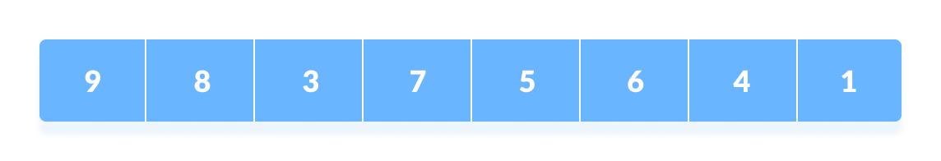

Rearrange all the elements at n/2 interval
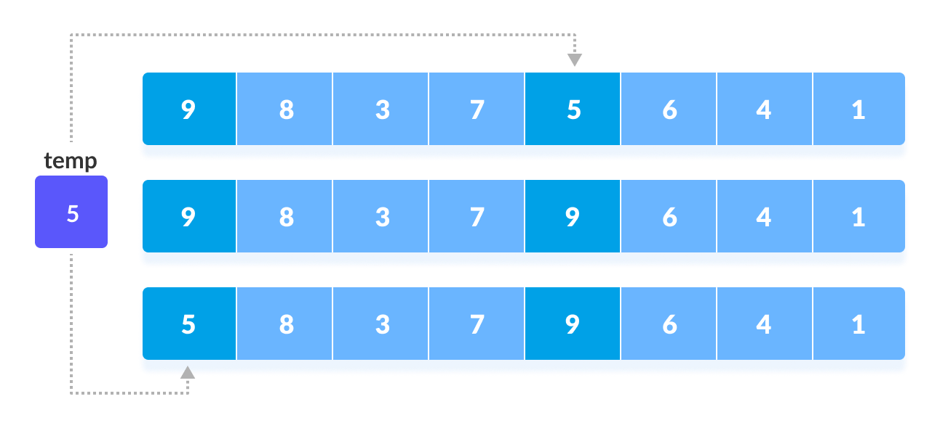
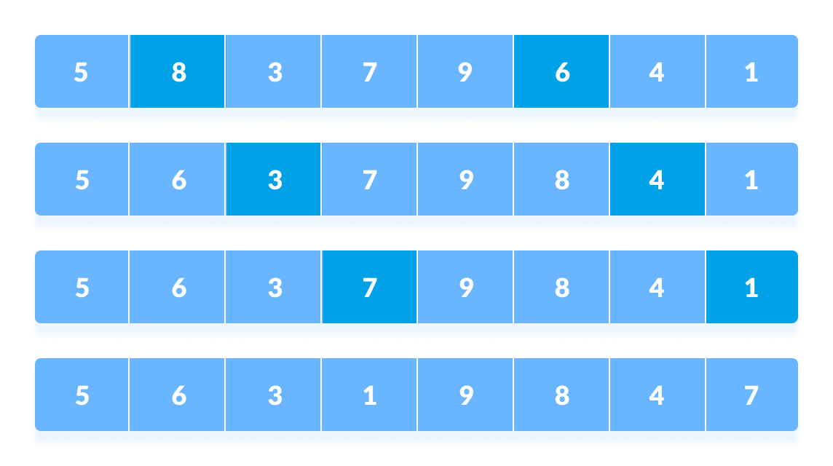

Rearrange the elements at n/4 interval
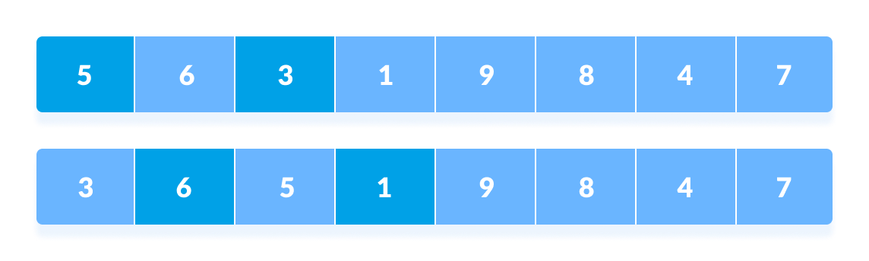
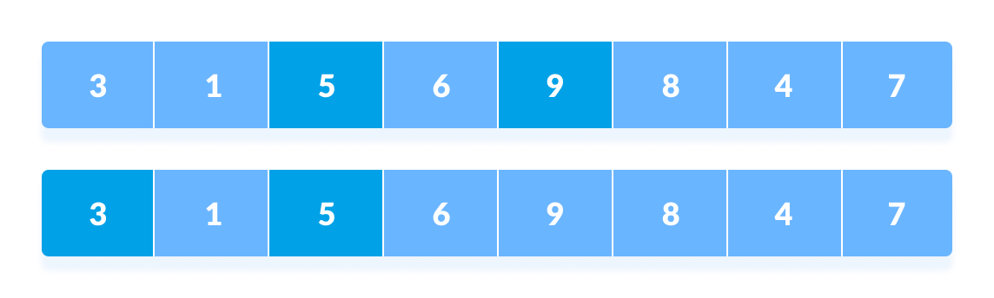
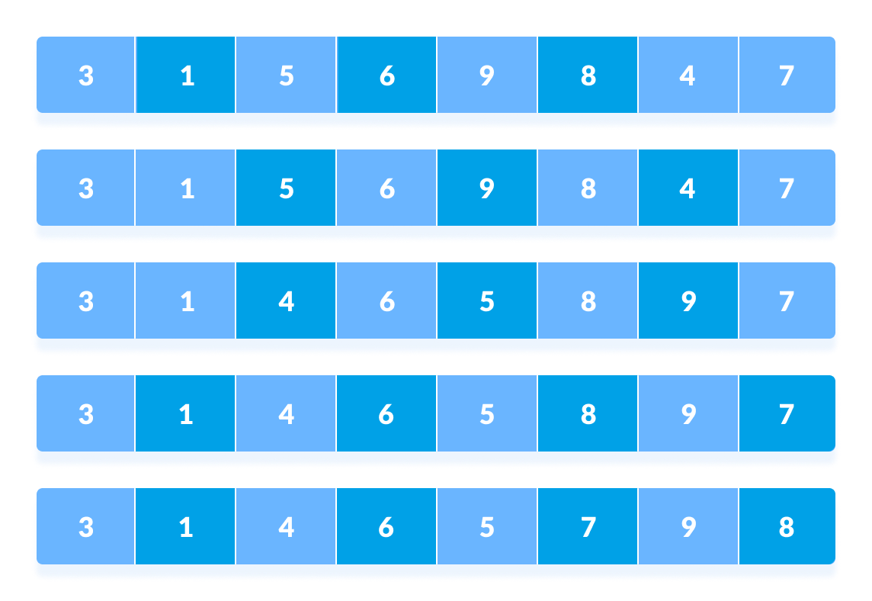

Rearrange the elements at n/8 interval
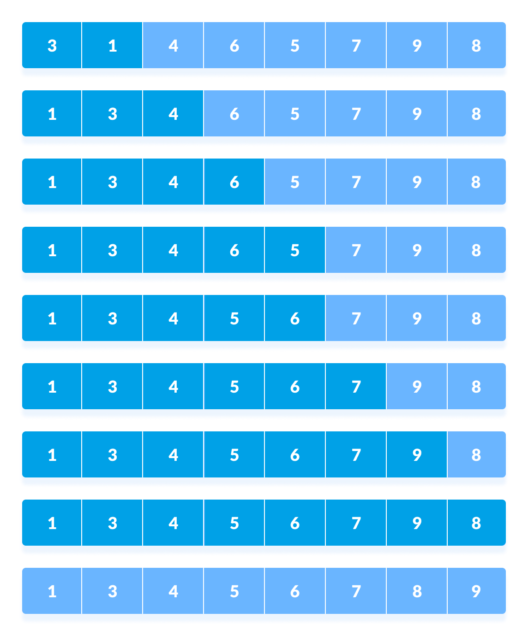

Example:

#include <iostream>
using namespace std;

void shellSort(int array[], int n) {
for (int interval = n / 2; interval > 0; interval /= 2) {
for (int i = interval; i < n; i += 1) {

for (int j = i-interval; j>=0;j=j-interval) {
if(array[j+interval]>array[j])
{
break;
}
else{
int temp=array[j];
array[j]=array[j+interval];
array[j+interval]=temp;

}
}

}
}
}
void printArray(int array[], int size) {
int i;
for (i = 0; i < size; i++)
cout << array[i] << " ";
cout << endl;
}

int main() {
int data[] = {9, 8, 3, 7, 5, 6, 4, 1};
cout<<"array without sorting:\n";
int size = sizeof(data) / sizeof(data[0]);
for(int i=0;i<size;i++)
{
cout<<data[i]<<" ";
}
shellSort(data, size);
cout << "\nSorted array: \n";
printArray(data, size);
}
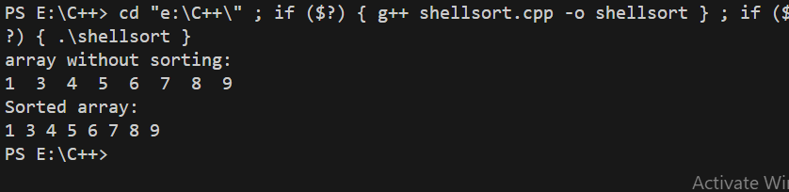

complexity
The time complexity of the code is O(n^2) in the worst case.

The outer loop iterates log(n) times, where 'n' is the size of the array. The reason is that the interval is divided by 2 in each iteration until it becomes 0. This results in a logarithmic number of iterations.

The inner loop has a worst-case time complexity of O(n) because it iterates over each element of the array once.

Therefore, the overall time complexity of the shell sort algorithm implemented in the given code is O(n^2), where 'n' is the size of the array.

